Enterprise Information System implementation in Rolls-Royce

Student:
Student ID:

Table of Contents
Introduction 3
ERP implementation through ICT in Rolls Royce 4
Issues faced for ERP implementation in Rolls Royce 6
Advantages of ERP in Rolls Royce 6
Conclusion 7
References 8

Introduction
Enterprise Resource Planning (ERP) is a computer based system which integrates resources of a company (Financial resources, Materials, Tangible assets and Human Resources). ERP is based on Relational DBMS (Database Management System) within client network architecture to provide important management data. Below given table classifies different types of benefits provided by ERP to organizations:
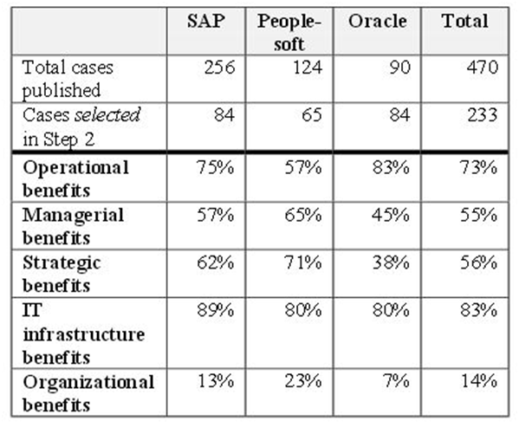
Source: Shang, S., & Seddon, P. B., AMCIS 2000

ERP provides access to the live data of all resources based on different modules which are integrated in ERP system. It enables firm to maintain smooth flow of information across all stake holders involved in business (suppliers, employees and customers). It also helps in automating business processes across the organization thus helping organization in improving its value chain. Author in this section has not provided any element of financial persuasion to supplement implementation of ERP in firms.

ERP implementation through ICT in Rolls Royce
Prior to implementation of ERP Rolls Royce relied on 1500 legacy systems and MERLIN. These systems involved lesser level of automation and it was often difficult to use them for decision making and performance evaluation. Entire IT department of Rolls Royce was outsourced to company called Electronic Data Services which was responsible for management and development of company’s IT system. Implementation of ERP in the firm was not an easy task there were various problems associated with the implementation of ERP. The process diagram to show this is as given below:

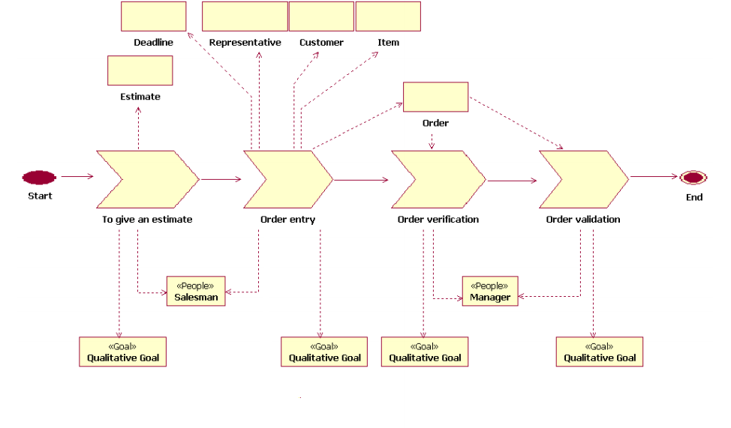

Meta Data Resource which will provide process maps and would act as intelligent repository to rule out contradiction between business systems may seem utopian concept to us. This is because of different kinds of semantics used in different business itself. Innovations in IT systems have attempted to generate a system which will solve this inconsistency in interaction of processes of different companies. Three systems which have played an important role in solving this discrepancy in business process are, Enterprise Resource Planning (ERP), Enterprise Application Integration (EAI) and Business Process Management (BPM). (Yusuf, Gunasekaran & Abthorpe, 2004)

ERP tried to solve this problem by using relational data base management systems with the expansion of businesses it tended to reinforce the lines between different business silos rather than integrating them. EAI then attempted to fill the gaps created by ERP. EAI was aided by emergence of internet it allowed extraction, translation, mapping along with conversion and consolidation but was unable to demolish business application silos. It made the problem even more complicated by enabling huge number of unregulated web services that not only used enterprise applications but also compromised them. BPM on the other hand started focusing on improvement of business process by enabling organization to set specific governing policies and within particular function of the organization. Problem with BPM was that while it focused on improving functional performance but was unable to overcome horizontal silos created. As BPM projects were implemented in different areas they were not able to benefit of central governing policies. The business process activity diagram is as given below:

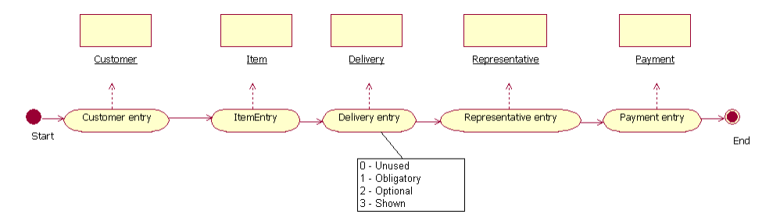

Solution of the problem lies in BPM itself. Concept of Meta BPM could be implemented by collaboration among BPM practitioners and intelligent use of information. This would allow creation of process repository. Process repository would be accessed by people in resolving conflicts and creating new mappings by their process data analysis. Although the success of Meta BPM is still untested, but it provides the most realistic opportunity to demolish the businesses silos and create consistent information system across the business world.

Issues faced for ERP implementation in Rolls Royce

Problems associated with implementation were mainly classified in three categories. First was cultural problem which included training of entire workforce on new system which requires huge cost. Second type of problem was business problem in which cost of switching to new system from old system was very high. Third type of problem was technical problem in which data management was biggest concern. (Mumford, 2001)

ERP implementation in Rolls Royce was made based on three suits based on different levels of implementation. Once all three levels were implemented ERP pilot was launched in Rolls Royce to display business frame work, principles and procedures to users and detect problems related to authorization, transaction and its accuracy to transfer data from older systems.

After the pilot project and successful launch of ERP, Rolls Royce was able to increase its sales by gathering more orders because ERP was adopted around the world by its supplier and its customers. ERP further enabled to simplify its business process and helped Rolls Royce in establishing accurate information systems and effective communication with all stake holders.

Advantages of ERP in Rolls Royce

In past ERP systems have emerged as an important tool for improving and integrating business process for Rolls Royce Enterprise systems such as ERP has provided organizations with improved flow of information to manage their value chain effectively. Current concepts of ERP, ERP 2, and ERP 3 have been extended to include to the resources used in different industrial sectors. Whereas IERP is specifically designed for particular industry to meet its specific needs. Future trends where there are huge growth prospects for ERP in Rolls Royce are: (Haug, Stentoft & Pedersen, 2009)

Conclusion

ERP provides access to the live data of all resources based on different modules which are integrated in ERP system. It enables firm to maintain smooth flow of information across all stake holders involved in business (suppliers, employees and customers). Other trends which could shape the future of ERP are mobile ERP, Big data and business intelligence. Cloud ERP could extremely useful in cutting cost of ERP infrastructure. It could be implemented in three forms, Software as service, Platform as a service and Infrastructure as a service. Mobile ERP can provide access to ERP software on mobiles. This will enable stakeholders across organization to access live data at any location and at any time. It would extend the access of ERP system beyond organizations. Organizations can now make use of large amount of data available to them to make meaning full business decisions. Big data and Business intelligence provides various tools for data analytics to assist in decision making process. So, it can be said that ERP is helping Rolls Royce for its overall growth.

References
- Haug, A., Stentoft Arlbjørn, J., & Pedersen, A. (2009). A classification model of ERP system data quality. Industrial Management & Data Systems, 109(8), 1053-1068.
- Mumford, E. (2001). Advice for an action researcher. Information Technology & People, 14(1), 12-27.
- Yusuf, Y., Gunasekaran, A., & Abthorpe, M. S. (2004). Enterprise information systems project implementation:: A case study of ERP in Rolls-Royce. International Journal of Production Economics, 87(3), 251-266.

